Mala Questionnaire
Finding the stone that will connect to you!

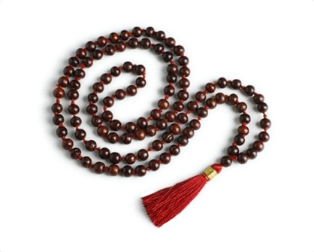
*You can select more than 1 answer*

- Currently, what is your emotional state?

- Very happy overall, can’t complain about much!
- Experiencing waves of depression/anxiety/fear or all together
- Pretty content, but want to be more connected with myself and others
- Going through many emotional ups & downs

- What are your favorite colors to wear right now (jewelry & clothing)?

- Neutrals mostly, pretty simple (black, grey, white, brown, taupe/beige/ navy)
- Bright, fun, vibrant colors (hot pink, salmon, yellow, orange, etc).
- I don’t think much into colors to wear.
- All depends on my mood each day!

- We have 7 chakras; each chakra represents a point on our body that helps our align our overall energy. Below, select each answer that fits with you currently (right Y or N, if you feel uncomfortable answering a Q feel free to skip).

- I have trouble communicating with others
- It is challenging for me to speak the truth to others
- It is difficult for me to be honest with myself
- I currently feel disconnected with myself
- I currently feel disconnected with others
- It is hard for me to love myself
- My sex drive is low right now
- I consider myself to be self-aware
- I always feel secure
- My impulses usually get the best of me
- I am not religious, but believe in a higher being
- I don’t really have an opinion on religion or higher being
- I feel tired and exhausted
- I tend to give too much energy to others
- I am confident physically
- I get stressed easily
- If in a stressful situation, I am calm and levelheaded

- Do you currently have any health conditions such as (heart problems, breathing, throat, reproductive, stomach, etc. feel free to just state the illness/problem & explain).

- Do you meditate? If Y how often?

Return To: jrwoodward94@gmail.com

